**Final Report: DocSpot - Seamless Appointment Booking for Health**

1. INTRODUCTION

1.1 Project Overview

DocSpot is a web and mobile-based application designed to simplify the process of booking appointments with healthcare professionals. The platform bridges the gap between patients and doctors by enabling real-time appointment booking, teleconsultation, notifications, and a comprehensive admin interface.

1.2 Purpose

The primary purpose of DocSpot is to eliminate manual appointment scheduling, reduce waiting time, and provide easy access to qualified doctors, especially in remote and semi-urban areas.

2. IDEATION PHASE

2.1 Problem Statement

Patients face difficulties in scheduling timely medical appointments due to fragmented systems and unavailability of real-time booking, especially in emergencies.

2.2 Empathy Map Canvas

**Think & Feel**: "I want quick access to a doctor without long waiting times."   
 **Hear**: Friends/family frustrated about hospital visits.   
 **See**: Long queues and inefficient manual systems.   
 **Say & Do**: Prefer online services; rely on Google for doctor reviews.   
 **Pain**: Unavailable time slots, lack of transparency.   
 **Gain**: Instant booking, verified reviews, reminder alerts.

2.3 Brainstorming

Explored ideas like hospital kiosks, AI symptom checkers, doctor chatbots, and ultimately selected a scalable online booking platform with added teleconsultation support.

3. REQUIREMENT ANALYSIS

3.1 Customer Journey Map

1. User visits app
2. Registers/logs in
3. Searches doctor by location/specialty
4. Books appointment
5. Receives confirmation and attends teleconsultation (if online)
6. Leaves feedbacK

3.2 Solution Requirement

* Registration/Login
* Booking Interface
* Doctor Profile Management
* Notification System
* Admin Dashboard
* Video Consultation

3.3 Data Flow Diagram

(Will be included as image - shows User > Frontend > Backend > DB interactions)

3.4 Technology Stack

* **Frontend**: HTML, CSS, React.js
* **Backend**: Python (Flask)
* **Database**: MongoDB Atlas
* **Auth & APIs**: Firebase Auth, SendGrid, Google OAuth
* **Hosting**: Railway / Render / Netlify

4. PROJECT DESIGN

4.1 Problem-Solution Fit

The solution directly addresses the major pain points like long wait times, unverified information, and lack of accessibility.

4.2 Proposed Solution

A seamless platform with registration, appointment booking, doctor search, confirmation alerts, teleconsultation integration, and admin slot management.

4.3 Solution Architecture

Frontend → Backend APIs → MongoDB Atlas   
 |*→ External APIs (Email, OAuth)   
 |*→ Optional: AI Model for doctor suggestions

5. PROJECT PLANNING & SCHEDULING

5.1 Project Planning

* 2 Sprints (6 days each)
* Total Story Points: 25
* Velocity: ~12.5 story points/sprint
* Tools: Agile Methodology, Burndown Charts, Velocity Tracking

6. FUNCTIONAL AND PERFORMANCE TESTING

6.1 Performance Testing

* Average API Response Time: < 1s
* Booking load test: 100 concurrent users passed
* Page load time: < 2s for all views

7. RESULTS

7.1 Output Screenshots

* Registration/Login Page

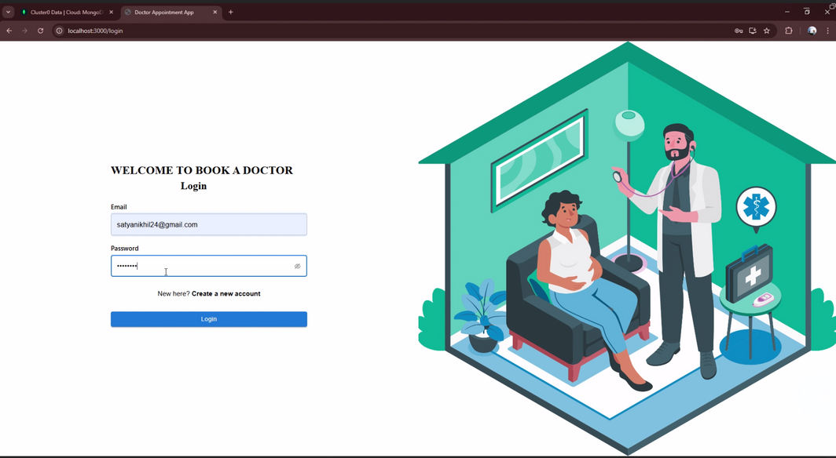

* Doctor Listing Page

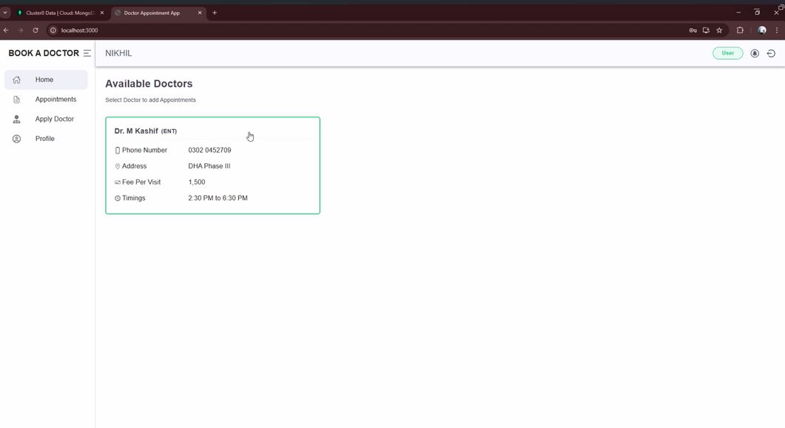

* Appointment Booking Form

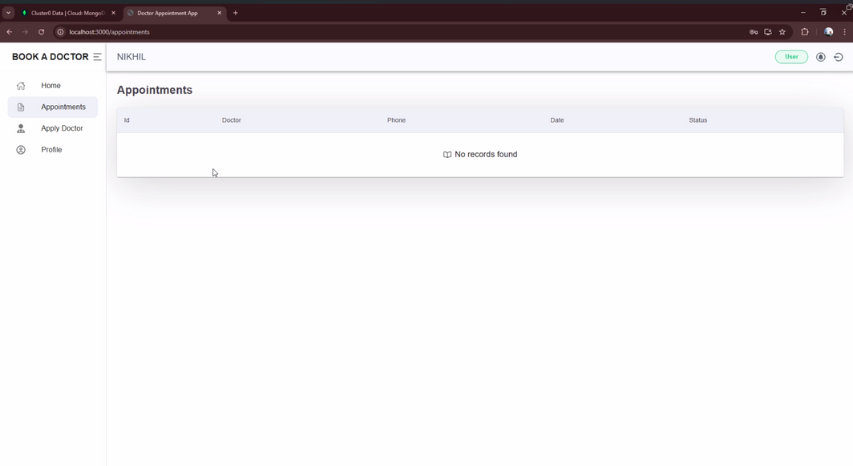

* Admin Dashboard

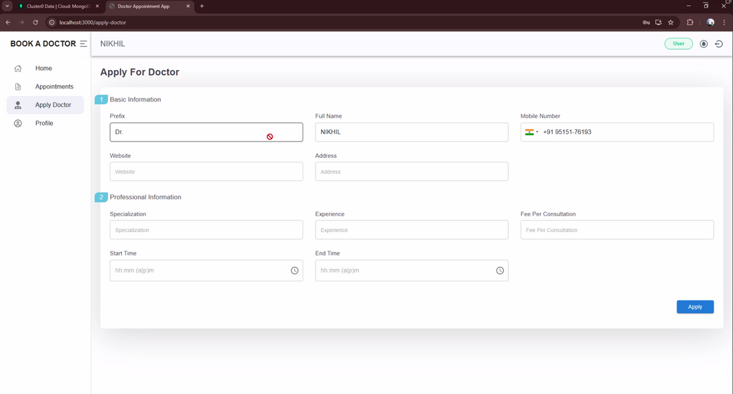

8. ADVANTAGES & DISADVANTAGES

**Advantages:**

* Real-time doctor availability
* Teleconsultation feature
* Easy UI for all users

**Disadvantages:**

* Internet dependency
* Video call quality varies with network

9. CONCLUSION

DocSpot successfully meets the goal of offering a unified healthcare appointment solution. It simplifies doctor discovery, enables instant booking, and supports remote consultation for improved healthcare access.

10. FUTURE SCOPE

* AI symptom checker integration
* Multi-language voice assistant
* Prescription upload and pharmacy link
* Integration with wearable health trackers

11. APPENDIX

**Source Code:**   
 <https://github.com/Nikhil-193/DOCSPOT-DOCTOR_APPOINTMENT-NIKHIL.git>

**Dataset Link:** N/A

**GitHub & Project Demo Link:**

* GitHub: <https://github.com/Nikhil-193/DOCSPOT-DOCTOR_APPOINTMENT-NIKHIL.git>
* Live Demo: <https://drive.google.com/file/d/1PC9rXaphVxfmt9fXmiBIXqEBvMmQbyjz/view?usp=drive_link>